Use Case Diagram: Main page
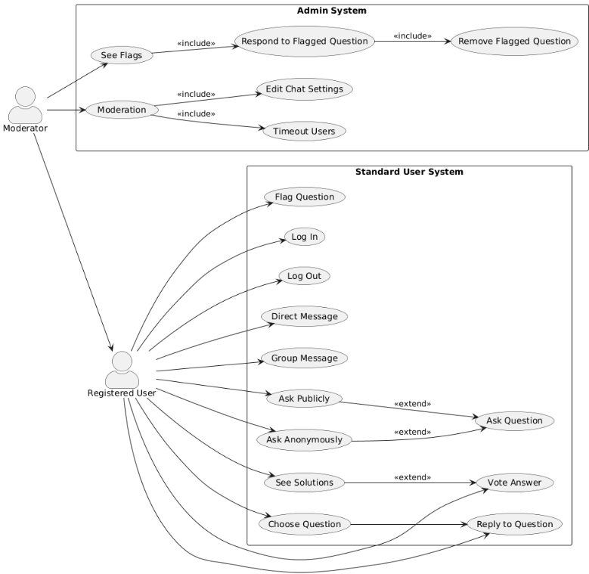
Official UCD list:

Name/Title: | Log In
ID: | 1
Description: | This allows a registered user that is not logged in to enter their information and log in.
Related Use Cases: | Instance of: None  Included by: None  Inclusions:None  Extensions: None
Precondition: | The user must have an account already created, and open the app not logged in.
Success Postcondition: | The user must gain access to their account.

USER STEPS:  1. The user will click the log in button since they have an account.  3a. The user enters their information.  3b. The user confirms their log in attempt. | SYSTEM RESPONSE:  2. The screen will change to allow the user to enter their information.  4.The user takes over their account linked to login info.  5.The user is pushed to the home screen of the app.

Name/Title: | Log out
ID: | 2
Description: | This allows the user to log out of their account so that they could possibly change accounts or if they prefer to stay logged out.
Related Use Cases: | Instance of: None  Included by: None  Inclusions:None  Extensions: None
Precondition: | The user must have an account, and be logged into the app.
Success Postcondition: | The user will be signed out and are prompted to either create an account or sign in.

USER STEPS:  1a. The user hovers over their account.  1b.The user clicks on settings, navigating to account settings.  3. The user clicks log out. | SYSTEM RESPONSE:  2a. The system drops a menu showing a log out option.  2b.the settings open showing all setting options.  4.The system removes the user from said account .  5. The user is set back to the log in or register screen.

Name/Title: | Ask Question
ID: | 3
Description: | The user can type out and post questions to be answered. This will take a Q & A voting format where people can answer the asked question and vote on answers.
Related Use Cases: | Instance of:<7,Ask anonymously>  Included by: None  Inclusions:None  Extensions: None
Precondition: | The user must have a registered account, and be on the Q & A page.
Success Postcondition: | The user posted an interactable question that other users can interact with.

USER STEPS:  1. The user will click the ‘create question’ button.  3. The user fills out their question in the given text box.  3.1. The user click the “anonymous mode” button at the top of the interface  4.The user clicks the post button | SYSTEM RESPONSE:  2. A creation interface will pop up.  5. The question is shared with other users to view and interact with publicly.

Name/Title: | Choose Question(Search questions)
ID: | 4
Description: | This is where if anyone has a question related to comp sci or programming that may be common, you can search and find it. If you want a specific language or problem that can be filtered for.
Related Use cases: | Instance of: None  Included by: None  Inclusions:None  Extensions: <5,Reply to Question>
Precondition: | The user has the app open, and has opened the questions tab.
Success Postcondition: | Users can see results similar to question search.

USER STEPS:  1. The user opens the questions tab from the main page.  3. Navigates to the search bar, activates with a toggle.  5.Clicks the search button | SYSTEM RESPONSE:  2. Open questions page where people post and interact with a list of questions by clicking on said questions.  4. Opens the search bar and displays what is typed.  6. Fetches and displays relevant information based on search keywords.

Name/Title: | Reply to Question
ID: | 5
Description: | This should be a core interaction function where people can leave comments under questions. This will allow people to share answers or feelings which is just as a needed function for our app.
Related Use Cases: | Instance of:  Included by: None  Inclusions:None  Extensions: <4,Choose question>
Precondition: | The user has the app open, and is looking at questions.
Success Postcondition: | Users can type in the comment box below questions, and share.

USER STEPS:  1. See question, click to open.  3.Click on the text box and type a comment.  5. Share comments. | SYSTEM RESPONSE:  2. Open question interface with a text box on bottom.  4. Open the comment box then write the text.  6. Shows comments under said post.

Name/Title: | See Solutions
ID: | 6
Description: | When a user asks a question, users can answer it under the question, in a comment section which a user can open to see given solutions.
Related Use Cases: | Instance of: None  Included by: None  Inclusions:None  Extensions: <8,Vote Answer>
Precondition: | The user must be logged in, and viewing questions.
Success Postcondition: | The user can open comments to any given post, and view/interact with the comments.

USER STEPS:  1. The user will open the comment section of a question. | SYSTEM RESPONSE:  2. The app opens showing the comments listed.  2.1. These will be organized by the voting feature.

Name/Title: | Ask Anonymously
ID: | 7
Description: | This feature should allow users that want to share anything have the option to toggle an anonymous feature. By having changing temp ids take the place of users we can boost confidence and interaction.
Related Use cases: | Instance of: None  Included by: None  Inclusions:None  Extensions: <3,Ask Question>
Precondition: | The user has the app open and has been prompted to create a post or comment.
Success Postcondition: | When a question is posted, the user's account is successfully hidden.

USER STEPS:  1. Clicks create question  3. Click the anonymous toggle within question.  5. Post question and share | SYSTEM RESPONSE:  2. Opens question creation interface  4. Change toggle button to on and place temporary filler id over the users account  6. Share what user posted with anonymous identity

Name/Title: | Vote Answer
ID: | 8
Description: | This feature will allow users to click a good and bad reactionary button that's on each question or comment. This will allow people to express themselves, organize correct or incorrect answers and do the same for good information or bad information.
Related Use Cases: | Instance of: <6,See solutions>  Included by: None  Inclusions:None  Extensions: None
Precondition: | The user has the app open, and is scrolling questions from a search or a board.
Success Postcondition: | Users can click an upvote or downvote button on any question or comment.

USER STEPS:  1.User searches for a question.  3. The user is looking at questions and clicks on given upvote downvote buttons attached to all questions and comments. | SYSTEM RESPONSE:  2.App shows comments.  4. Reacts by adjusting ui to show reaction, and updates count of reactions and refilters comments on reaction count.

Name/Title: | Direct Message
ID: | 9
Description: | This is a private communication feature where from someone's profile directly, or from the messages tab, you can send messages. This is useful for users who prefer private communication and maybe to help specify certain issues more clearly.
Related Use cases: | Instance of: None  Included by: None  Inclusions:None  Extensions: None
>Precondition: | The user has an account, and has someone to message.
Success Postcondition: | Users can privately message other users.

USER STEPS:  1. The user clicks on the messages button/tab.  3.Open chat with the wanted recipient.  5. Type in the text box whatever message and hit enter, or share button. | SYSTEM RESPONSE:  2. This opens the messages page showing a list of users previous messages, and a way to search for users to message.  4. Show previous messages, and a text box.  6. The message box will receive the text, then share the message with other user. Sharing it in their messages tab.

Name/Title: | Group Message
ID: | 10
Description: | This is the group message future where multiple users can chat in one space.
Related Use Cases: | Instance of:None  Included by: None  Inclusions:None  Extensions: None
Precondition: | A user must have multiple people to chat with.
Success Postcondition: | A user shares a message that is received by multiple people.

USER STEPS:  1. The user navigates to the group messaging feature.  2.The user selects a chat, and types their message.  3.The user shares their message | SYSTEM RESPONSE:  4.The system shares the message so that it is visible to all members within the chat.

Name/Title: | See flags
ID: | 11
Description: | The user should be able to check any flagged questions or comments
Related Use Cases: | Instance of:None  Included by: None  Inclusions:<12,Respond to Flagged Question>  Extensions: None
Precondition: | User is an admin within the specified group and on the group’s page
Success Postcondition: | User is able to view a list of flagged questions and comments

USER STEPS:  1. click the ‘flags’ button on the left sidebar  3. Click on desired post with flags | SYSTEM RESPONSE:  2. open the flags page containing any posts that have flags that have not been resolved  4.Bring the user to the specified post and highlight any flags with any comments made on said flags below them

Name/Title: | Respond to flagged Question
ID: | 12
Description: | Admins can choose to leave or remove flagged questions.
Related Use Cases: | Instance of:  Included by: <11, See Flags>  Inclusions:<14,Remove Flagged Question>  Extensions: None
Precondition: | The user has admin controls, there is a flagged message to be subject of moderation and the user is looking at the flagged questions page
Success Postcondition: | The admin passes or returns the question.

USER STEPS:  1. The admin clicks on flagged question  3a. The admin decides to pass the flagged question.  3b.The admin returns the question that contains flags. | SYSTEM RESPONSE:  2. The system displays questions with flagged text highlighted.  4a. The system passes the question.  4b.The system returns it to the User.  4.1.This will notify the user that sent the flagged message regardless of outcome.

Name/Title: | Timeout Users
ID: | 13
Description: | The user should be able to timeout a user, stopping them from commenting or posting questions.
Related Use Cases: | Instance of: None  Included by:  Inclusions:None  Extensions: None
Precondition: | The user must have admin permissions.
Success Postcondition: | The user can stop another user from interacting on the app for a given period of time.

USER STEPS:  1. The user will click on the user profile.  1.1. The admin can get here from an asked question, or flagged posts.  3. The click ‘timeout user’.  5. The admin will fill out necessary sections such as reason, length of timeout, and confirm. | SYSTEM RESPONSE:  2. The system will display the user’s profile with selections that contain set timeout periods.  4.The system will show the timeout settings.  6.The user will be blocked from interactive permission for the entered period of time.

Name/Title: | Remove flagged questions
ID: | 14
Description: | An admin should be able to remove any flagged questions if they deem it appropriate
Related Use Cases: | Instance of: None  Included by: <12,Respond to Flagged Questions>  Inclusions:None  Extensions: None
Precondition: | The user is an admin in a group and viewing their group’s page.
Success Postcondition: | The specified post is removed from the group page.

USER STEPS:  1. Click the question that has been flagged.  1.1.This could also just be pulled from any regular question interaction at admins discretion.  3. The admin will click the options button on the question.  4.The admin will then click the ‘remove question' button.  5. Admin clicks that they are sure. | SYSTEM RESPONSE:  2. The question will be opened.  2.1.There will be options here to open a menu with options such as view profile, or remove question.  5.The system will prompt if the admin is sure they want to remove the question.  6.Question is removed from any public space.

Name/Title: | Edit Chat Settings
ID: | 15
Description: | This is useful so that within certain spaces, or within posted questions, if a certain word needs to be blacklisted or such, the admin can access these settings.
Related Use Cases: | Instance of: None  Included by:  Inclusions:None  Extensions: None
Precondition: | The user must have admin permissions, and there must be a relevant space to edit the chat settings from.
Success Postcondition: | The settings must be put in place so that appropriate posts are flagged.

USER STEPS:  1. The admin will enter the question page.  2.The admin will then click on the settings option for that page.  4.The admin will select edit chat settings.  5. The user will add a new word to the list of disallowed words and confirm. | SYSTEM RESPONSE:  3.A settings dropdown will show for the user.  5.The chat settings will appear.  6.The system will put the new settings in place, now flagging all appropriate questions.

Name/Title: | Flag Question
ID: | 16
Description: | This feature should allow users to toggle a flag on posts that are deemed not safe for work, or against policies.
Related Use cases: | Instance of: None  Included by: None  Inclusions:None  Extensions: None
Precondition: | The user is on the question post screen and has selected a question that violates company policies.
Success Postcondition: | An admin has been notified with a message that there is action that is needed in the list of questions.

USER STEPS:  1. The user clicks on a question.  3.The user clicks on the flag toggle | SYSTEM RESPONSE:  2. The system displays the question and comment screen  4. The system displays a checked box next to the flag icon

___________________________________________________________

